Cisco phones available for purchase through Telephone Services

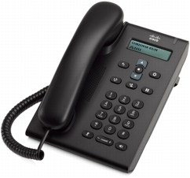Cisco 3905 (single line phone) @ $60

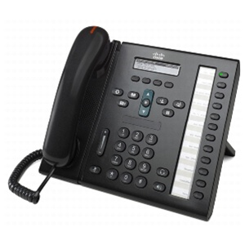Cisco 6961 (12 button phone) @ $170

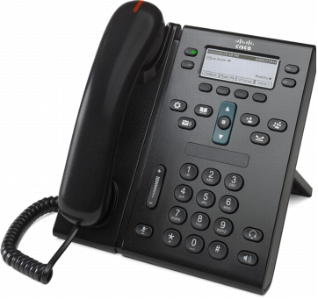Cisco 6945 (4 button phone) @ $220

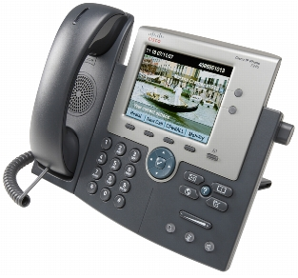Cisco 7945 (2 button, color display) @ $270

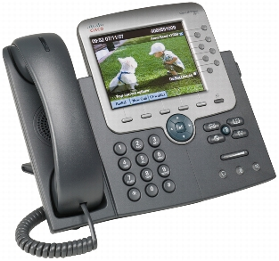Cisco 7975 (8 buttons, color touch screen display) This phone can be expanded by using up to 2 sidecars. $390

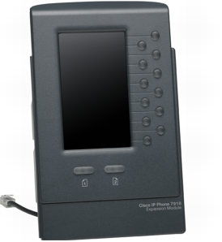Cisco 7916 sidecar (24 buttons – 12 buttons with 2 levels)
$280

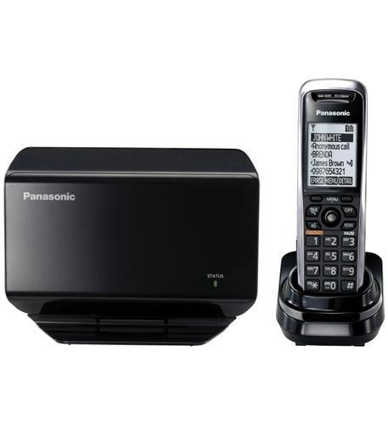
Panasonic KX-TGP500B04 VoIP Cordless Telephone Base Unit. $220
This phone is expandable with 5 extension handsets, up to 8 lines.
Cordless phone extension - PNT-KX-TPA50B04. $110

